ABSTRACT
In today’s digital environment, safeguarding sensitive data stored on computer systems is a major security concern. Conventional file protection techniques such as manual encryption, password-protected folders, or hidden files are often insufficient and highly dependent on user awareness. These methods are prone to human error and may leave confidential data exposed for long periods.
This project presents an Automatic File Protection System that ensures real-time security of files using encryption and controlled access. The system continuously monitors a protected directory and automatically encrypts any newly created file without requiring user intervention. Encrypted files are stored in an unreadable cipher format and are hidden from normal view. To access a protected file, the user must authenticate using a password through a secure file opener utility. Once the file is accessed and closed, it is automatically re-encrypted and restored to its protected state.
The system also maintains a security log to record file encryption, access attempts, and re-encryption events with timestamps. This project demonstrates the practical application of cybersecurity principles such as encryption, automation, access control, and security auditing to protect sensitive data effectively.
Additionally, the system maintains a security log that records important events such as file encryption, access attempts, and re-encryption operations along with timestamps. This logging mechanism enables auditing, monitoring, and basic forensic analysis. The project effectively demonstrates the practical application of cybersecurity principles such as encryption, automation, access control, and security auditing to protect sensitive data in a reliable and efficient manner
Chapter 01
INTRODUCTION
With the rapid advancement of information technology, large volumes of data are created, stored, and shared digitally on a daily basis. This data often includes sensitive information such as personal documents, academic records, financial details, and confidential project files. Protecting such data from unauthorized access, accidental exposure, and malicious attacks has become a critical requirement in both personal and professional computing environments.
In many existing systems, file security is largely dependent on manual actions performed by users, such as encrypting files, setting passwords, or hiding folders. These approaches are not only time-consuming but also unreliable, as users may forget to apply protection consistently. Furthermore, once a file is decrypted for use, it often remains exposed on the system until the user manually re-encrypts it, increasing the risk of data leakage.
The Automatic File Protection System is designed to overcome these limitations by introducing automation into the file security process. Instead of relying on user discipline, the system actively monitors a designated protected folder and enforces encryption immediately when a file is created. This ensures that sensitive data is always stored in an encrypted format and is never left unprotected.
The system also incorporates controlled access mechanisms that allow only authorized users to view protected files. By combining real-time file monitoring, cryptographic encryption, password-based authentication, and automatic re-encryption, the project provides a robust and practical solution for securing files on a local system. This project emphasizes the application of cybersecurity principles in a real-world scenario, making it both technically relevant and practically useful.

Chapter 02
PROBLEM STATEMENT
In many existing computer systems, file security is primarily dependent on manual protection techniques such as password-protected folders, manual encryption tools, or simply hiding files. These methods are often unreliable because they require continuous user involvement and awareness. If a user forgets to encrypt a file or leaves it decrypted after use, sensitive information becomes immediately vulnerable to unauthorized access.
Hidden files do not provide real security, as they can easily be revealed by changing system settings. Similarly, manual encryption solutions require users to repeatedly encrypt and decrypt files, which is inconvenient and prone to human error. Once a file is decrypted for viewing or editing, it often remains in plaintext form on the system until the user manually re-encrypts it, significantly increasing the risk of data leakage.
Another critical limitation of existing file protection mechanisms is the absence of automated monitoring and auditing. Most traditional systems do not record file creation, access attempts, or modification activities. Without proper logging, it becomes difficult to track file usage, identify unauthorized access attempts, or perform security audits and forensic analysis after a security incident.
Additionally, many systems fail to provide continuous protection. Files may remain unprotected for a certain period between creation and manual encryption, during which they can be accessed or copied by unauthorized users. This time gap represents a serious security vulnerability.
Therefore, there is a strong need for an automated file protection system that eliminates reliance on manual actions. Such a system should ensure that files are encrypted immediately upon creation, remain unreadable to unauthorized users, provide controlled access through authentication, automatically re-encrypt files after use, and maintain detailed security logs. Addressing these challenges is essential to improve data confidentiality, integrity, and overall system security.

Chapter 03
OBJECTIVES
The primary objective of the Automatic File Protection System is to provide a secure and automated mechanism for protecting sensitive files stored on a local system. The system is designed to ensure that files are never left exposed in plaintext form and that access is strictly controlled through authentication.
3.1 Primary Objectives
• To design and implement a system that continuously monitors a protected folder for newly created files
• To automatically encrypt files immediately after creation without requiring manual user intervention
• To ensure that encrypted files remain unreadable and inaccessible to unauthorized users
• To provide password-based authentication for controlled file access
• To automatically re-encrypt files after legitimate access is completed
• To prevent accidental or intentional exposure of sensitive data
3.2 Secondary Objectives
• To eliminate reliance on manual encryption and decryption processes
• To minimize human error in file security practices
• To maintain a detailed security log recording file encryption, access attempts, and re-encryption events
• To enable basic auditing and monitoring of file-related activities
• To demonstrate practical implementation of cybersecurity concepts such as encryption, access control, and automation
3.3 Project-Specific Objectives
• To ensure files remain encrypted at rest at all times
• To ensure unauthorized users can only view cipher text even if they access the file directly
• To reduce the time window during which sensitive files are exposed
• To provide a simple and efficient command-based interface for secure file access

Chapter 04
SYSTEM ARCHITECTURE
The Automatic File Protection System follows a modular and layered architecture to ensure reliability, security, and ease of maintenance. Each component of the system has a clearly defined role, and together they form a complete automated file security solution. The architecture is designed to separate monitoring, encryption, access control, and logging functionalities, which improves system stability and scalability.
At a high level, the system consists of four main components: the Protected Folder, the File Watcher Module, the Secure File Opener Module, and the Security Logging Module.
4.1 Protected Folder
The Protected Folder is a designated directory on the system where sensitive files are stored. Any file created inside this folder is automatically subjected to security enforcement. Users interact with this folder in a normal manner by creating or saving files, without needing to manually apply any protection.
4.2 File Watcher Module
The File Watcher Module runs as a background process and continuously monitors the Protected Folder for file creation events. When a new file is detected, the watcher immediately triggers the encryption process. The original plaintext file is removed, and an encrypted version of the file is created. System-level file attributes are applied to hide and protect the encrypted file from normal access.
This module ensures that files are never stored in an unprotected state on the disk.
4.3 Encryption Engine
The Encryption Engine is responsible for converting plaintext file data into encrypted cipher text using symmetric encryption techniques. A securely generated encryption key is stored separately and used for both encryption and decryption operations. The encrypted output ensures that even if the file is accessed directly, its contents remain unreadable without the correct key.
4.4 Secure File Opener Module
The Secure File Opener Module provides controlled access to encrypted files. When a user needs to access a protected file, they must supply the correct file path and password. Upon successful authentication, the file is temporarily decrypted and opened for viewing. Once the user finishes accessing the file, the system automatically re-encrypts it and restores its protected state.
This module ensures that file access is strictly authenticated and exposure time is minimized.
4.5 Security Logging Module
The Security Logging Module maintains a detailed record of all critical operations performed by the system. Events such as file encryption, access attempts, successful decryption, re-encryption, and errors are recorded along with timestamps. These logs provide visibility into system activity and support auditing, monitoring, and basic forensic analysis.
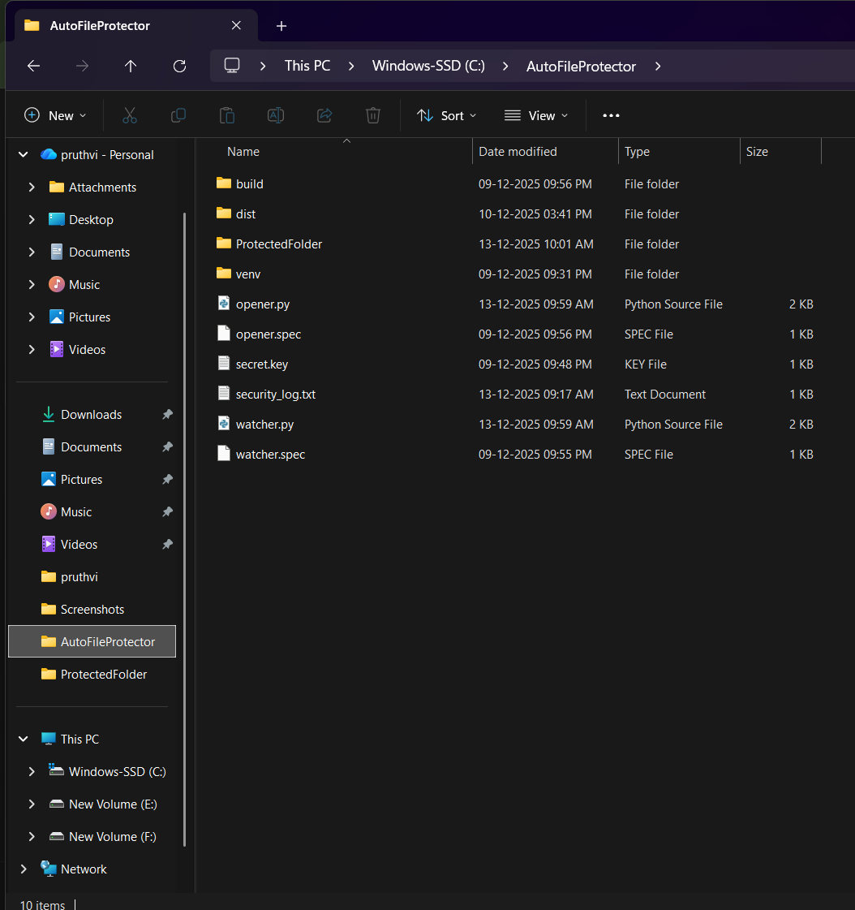
Fig 4.5.1
Chapter 05
METHODOLOGY / WORKING OF THE SYSTEM
The Automatic File Protection System operates through a sequence of automated steps that ensure files are protected throughout their lifecycle. The system workflow is designed to minimize user involvement while maintaining strong security controls. The overall working of the system can be divided into the following stages.
Step 1: System Initialization
When the system is started, the File Watcher module is launched as a background process. During initialization, the system verifies the presence of a secure encryption key. If the key does not exist, it is generated automatically and stored securely. The security log file is also initialized to record all future events.
At this stage, the system is ready to monitor the protected folder continuously.
Step 2: Real-Time Folder Monitoring
The File Watcher continuously monitors the Protected Folder for file creation events. This monitoring happens in real time, ensuring that no file remains unprotected for any significant duration. Users interact with the folder normally by creating or saving files without needing to trigger any security action manually.
This step ensures automation and eliminates dependency on user behavior.
Step 3: Automatic File Encryption
As soon as a new file is detected in the Protected Folder, the system reads the file content and encrypts it using symmetric encryption. The encryption process converts readable plaintext data into unreadable cipher text. After encryption, the original plaintext file is deleted from the system.
The encrypted file is stored with a protected extension and is hidden using system-level file attributes. This ensures that even if the folder is accessed, the encrypted files are not visible or readable by default.
Step 4: Secure File Storage
Once encrypted, the file remains securely stored in the Protected Folder in its encrypted form. At this stage, the file is completely unreadable if accessed directly. Renaming the file or attempting to open it using standard applications will only display cipher text, thereby preventing unauthorized data access.
This step ensures data confidentiality while the file is at rest.
Step 5: Authorized File Access
When a legitimate user needs to access a protected file, they use the Secure File Opener utility. The user must provide the full file path of the encrypted file along with the correct password. The system verifies the password before proceeding.
If the password is incorrect, access is denied and the attempt is recorded in the security log. The encrypted file remains unchanged.
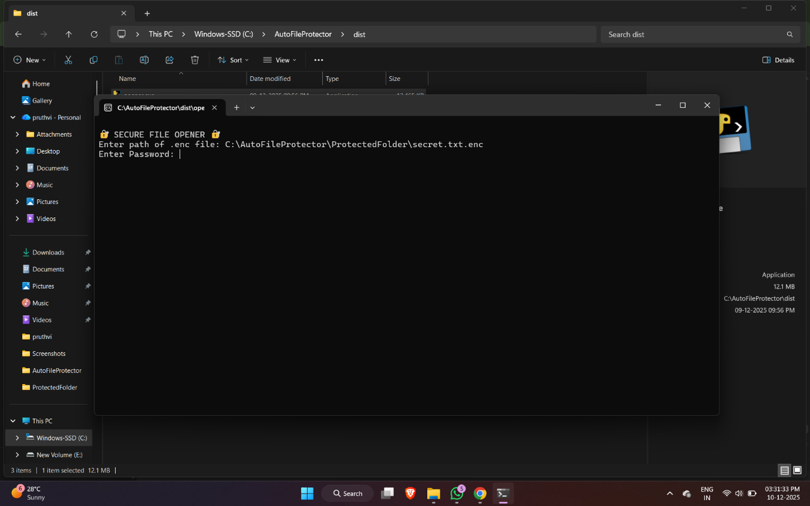
Fig 5.1

Step 6: Temporary Decryption and File Access
If the password verification is successful, the system temporarily decrypts the encrypted file and restores it to its original format. The file is then opened using a standard application for viewing or editing. During this time, the file exists in plaintext form only for the duration of authorized access.
This approach minimizes the exposure window of sensitive data.
Step 7: Automatic Re-Encryption
After the user finishes accessing the file and closes it, the system automatically re-encrypts the file using the same encryption key. The plaintext file is removed, and the encrypted version is restored with protective attributes applied again.
This step ensures that the file is never left unprotected after use.
Step 8: Security Logging
Throughout all stages of operation, the system records important events in a security log file. These events include system startup, file encryption, access attempts, successful decryption, and re-encryption. Each log entry is timestamped, enabling monitoring, auditing, and basic forensic analysis.
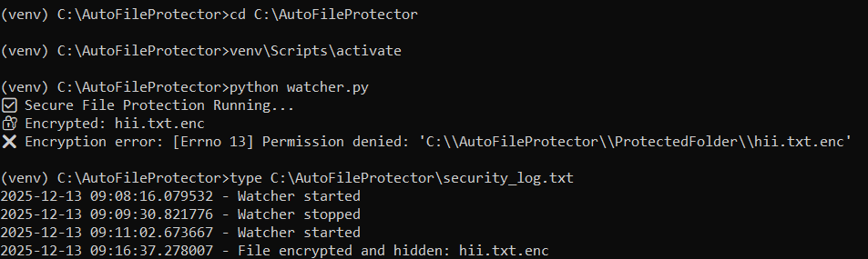
File 5.2

CHAPTER 6
MODULES DESCRIPTION
The Automatic File Protection System is developed using a modular approach, where each module is responsible for a specific functionality. This design improves clarity, maintainability, and security. The major modules of the system are the File Watcher Module, Encryption Module, Secure File Opener Module, and Security Logging Module.
6.1 File Watcher Module
The File Watcher Module is responsible for continuously monitoring the protected directory for any newly created files. This module runs in the background and operates without requiring user interaction. It detects file creation events in real time and immediately triggers the encryption process.
Once a new file is detected, the watcher ensures that the file is fully written before processing it. This prevents partial encryption or data corruption. After confirmation, the watcher passes the file to the encryption module for further processing.
The primary role of this module is to ensure that no file remains in plaintext form within the protected folder, even for a short duration.
6.2 Encryption Module
The Encryption Module is the core security component of the system. It is responsible for converting plaintext file content into encrypted cipher text using symmetric encryption techniques. A securely generated encryption key is used for both encryption and decryption processes.
When a file is received from the watcher module, the encryption module reads its content, encrypts it, and generates an encrypted version of the file. The original plaintext file is deleted to prevent data leakage. The encrypted file is stored with a protected extension and system-level attributes such as hidden, system, and read-only are applied.
This module ensures that even if an encrypted file is accessed directly, its contents remain unreadable without proper decryption.
6.3 Secure File Opener Module
The Secure File Opener Module provides controlled and authenticated access to encrypted files. This module is invoked when a user needs to access a protected file. The user must supply the full path of the encrypted file along with the correct password.
The module verifies the password before allowing access. If authentication fails, access is denied and the event is logged. If authentication is successful, the encrypted file is temporarily decrypted and opened for viewing or editing. The file remains in plaintext form only during the authorized access period.
After the user finishes accessing the file and closes it, the module automatically re-encrypts the file and restores its protected state. This minimizes the exposure of sensitive data and maintains continuous security.
6.4 Security Logging Module
The Security Logging Module is responsible for recording all critical security-related events within the system. This includes file encryption events, access attempts, successful decryption, re-encryption, and system startup or shutdown actions.
Each event is recorded with a timestamp in a dedicated log file. These logs provide visibility into system behavior and help in monitoring file activity. The logging mechanism supports auditing and can assist in identifying unauthorized access attempts or abnormal system behavior.
This module enhances accountability and aligns the system with real-world cybersecurity practices such as audit logging and incident tracking.

CHAPTER 7
RESULTS AND OUTPUT
This chapter presents the results obtained after implementing and testing the Automatic File Protection System. The system was tested under different scenarios to verify its functionality, security, and reliability. The results confirm that the system meets the intended objectives of automated file protection and controlled access.
7.1 Automatic File Encryption Result
When a new file is created inside the Protected Folder, the File Watcher Module immediately detects the event and encrypts the file. The original plaintext file is removed from the folder, and an encrypted version of the file is created. The encrypted file is stored with a protected extension and system-level attributes such as hidden and read-only.
This confirms that the system successfully enforces real-time encryption without requiring any manual action from the user.
7.2 Unauthorized Access Attempt Result
When an encrypted file is accessed directly without using the secure file opener, the file content appears as unreadable cipher text. Even if the encrypted file extension is modified, the content remains encrypted and cannot be interpreted.
This result demonstrates that the system effectively protects file confidentiality and prevents unauthorized users from reading sensitive data.
7.3 Authorized File Access Result
When the authorized user provides the correct file path and password through the Secure File Opener utility, the system successfully decrypts the encrypted file and opens it for viewing or editing. The file remains accessible only during the authorized session.
After the user finishes accessing the file and closes it, the system automatically re-encrypts the file and restores it to its protected state. This confirms that controlled access and automatic re-encryption are functioning as intended.

7.4 Security Logging Result
All critical system activities are recorded in the security log file. Events such as file encryption, authorized access, re-encryption, and failed access attempts are logged with accurate timestamps.
The presence of detailed log entries confirms that the system provides effective monitoring and auditing capabilities, which are essential for security analysis and incident tracking.
7.5 Overall System Performance
The system operates efficiently with minimal resource usage. File monitoring and encryption occur quickly, ensuring that files are not left exposed. The modular design allows smooth coordination between monitoring, encryption, access control, and logging components.
Overall, the results demonstrate that the Automatic File Protection System performs reliably and fulfills the core security requirements.

CHAPTER 8
ADVANTAGES AND APPLICATIONS
This chapter discusses the key advantages of the Automatic File Protection System and highlights its practical applications in real-world scenarios. The system provides an effective solution for securing sensitive data through automation and strong access control mechanisms.
8.1 Advantages of the System
Automation of File Security
The system automatically encrypts files as soon as they are created, eliminating the need for manual encryption. This reduces dependency on user awareness and prevents accidental exposure of sensitive data.
Strong Data Confidentiality
By using encryption, the system ensures that file contents remain unreadable to unauthorized users. Even if an encrypted file is accessed directly or renamed, only cipher text is visible.
Controlled and Secure Access
Access to protected files is strictly controlled through password-based authentication. Only authorized users can decrypt and view the file contents, ensuring secure access control.
Automatic Re-encryption
After the file is accessed and closed, it is automatically re-encrypted and restored to its protected state. This minimizes the time window during which sensitive data is exposed.
Security Logging and Auditing
The system maintains a detailed security log that records file encryption, access attempts, and re-encryption events with timestamps. This enables monitoring, auditing, and basic forensic analysis.
Reduced Human Error
Since encryption and protection are handled automatically, the system significantly reduces the risk of human error, which is a common cause of data leaks in traditional file security approaches.
Lightweight and Efficient
The system operates with minimal resource usage and does not require continuous user interaction, making it suitable for everyday use on personal and organizational systems.
8.2 Applications of the System
The Automatic File Protection System can be applied in various real-world scenarios, including:
Personal Data Protection
Protecting personal documents such as identity records, financial statements, and private files stored on personal computers.
Academic and Educational Use
Securing student project files, research data, internal assessments, and academic records from unauthorized access.
Organizational and Office Environments
Protecting confidential company documents, internal reports, and sensitive files in small-scale office environments.
Cybersecurity Learning and Demonstration
Demonstrating practical implementation of encryption, access control, automation, and security logging concepts for educational and training purposes.
Offline Data Security
Providing file protection in environments where internet-based security solutions are not available or required.

CHAPTER 9
CONCLUSION
The Automatic File Protection System successfully addresses the challenge of securing sensitive files stored on a local system by introducing automation and strong access control mechanisms. The project demonstrates how real-time file monitoring combined with encryption can significantly enhance data confidentiality and reduce the risk of unauthorized access.
By automatically encrypting files immediately after creation, the system ensures that sensitive data is never stored in plaintext form. The use of password-based authentication for file access further strengthens security by allowing only authorized users to view protected files. Additionally, the automatic re-encryption of files after use minimizes the exposure time of sensitive information and ensures continuous protection.
The inclusion of a security logging mechanism adds an additional layer of reliability by recording important system activities such as encryption, access attempts, and re-encryption events. These logs support monitoring, auditing, and basic forensic analysis, aligning the system with real-world cybersecurity practices.
Overall, the project effectively demonstrates the practical application of cybersecurity concepts such as encryption, automation, access control, and auditing. The system is lightweight, efficient, and suitable for personal, academic, and small organizational use. This project provides a strong foundation for further enhancements and serves as a valuable learning experience in secure system design.

CHAPTER 10
FUTURE ENHANCEMENTS
While the Automatic File Protection System successfully meets its current objectives, there are several enhancements that can be implemented in the future to further improve functionality, usability, and security.
One possible enhancement is the development of a stable graphical user interface (GUI) that allows users to manage file protection, start or stop monitoring, and access protected files more conveniently. A well-designed GUI would improve user experience while maintaining backend security.
Another enhancement involves implementing stronger authentication mechanisms, such as hashed passwords, multi-factor authentication, or user-based access control. This would allow multiple users with different privilege levels to access protected files securely.
The system can also be extended to include intrusion detection features, such as locking the file or system after multiple incorrect password attempts and generating alerts for suspicious activities. Email or notification-based alerts can further improve security monitoring.
Protecting the security log file itself is another important enhancement. Techniques such as log encryption, hashing, or access restriction can be implemented to prevent log tampering and ensure log integrity.
Additionally, the system can be expanded to support cloud-based or network storage environments, enabling secure file protection across multiple devices. Cross-platform support for operating systems such as Linux and macOS can also be considered.
Overall, these enhancements would make the system more robust, scalable, and suitable for enterprise-level applications while maintaining its core objective of automated file security.

CHAPTER 11
REFERENCES
The following references were used during the study, design, and implementation of the Automatic File Protection System. These sources provided theoretical background, implementation guidance, and best practices related to file security, encryption, and system monitoring.
- William Stallings, Cryptography and Network Security: Principles and Practice, Pearson Education.
- Python Software Foundation, Python Official Documentation
https://docs.python.org
- Python Cryptography Library Documentation
https://cryptography.io/en/latest/
- Watchdog Library Documentation – Python File System Monitoring
https://python-watchdog.readthedocs.io
- Microsoft Documentation, Windows File Attributes and Security
https://learn.microsoft.com
- NIST (National Institute of Standards and Technology),
Guide to Storage Encryption Technologies for End User Devices
- OWASP Foundation, Data Protection and Cryptographic Storage Guidelines

